Name : Sundaramoorthy S
Reg No : 192324228
Course code : Cloud Computing And Big Data Analysis
Exp No : EXPERIMENT 3
Date : 18/12/2025

EXPERIMENT 3
Title
Creation of a Simple Cloud Software Application for Property Buying and Rental System (Chennai City) to Demonstrate SaaS
Aim
To create and deploy a cloud-based Property Buying and Rental application for Chennai city using a Cloud Service Provider to demonstrate Software as a Service (SaaS).
Procedure
- Select a cloud service provider such as AWS / Azure / Google Cloud / Zoho Creator.
- Create a web-based application for property buying and rental.
- Design forms for property details, user details, and rental requests.
- Create a cloud database to store property and customer information.
- Deploy the application on the cloud platform.
- Allow users to access the application through a web browser.
- Store and retrieve data from the cloud database.
Sample Dataset
- Property ID: P101, Area: Velachery, Type: 2BHK, Purpose: Rent, Price: 18000
- Property ID: P102, Area: Tambaram, Type: 3BHK, Purpose: Buy, Price: 6500000
Output
- Property listing and rental request form displayed on cloud.
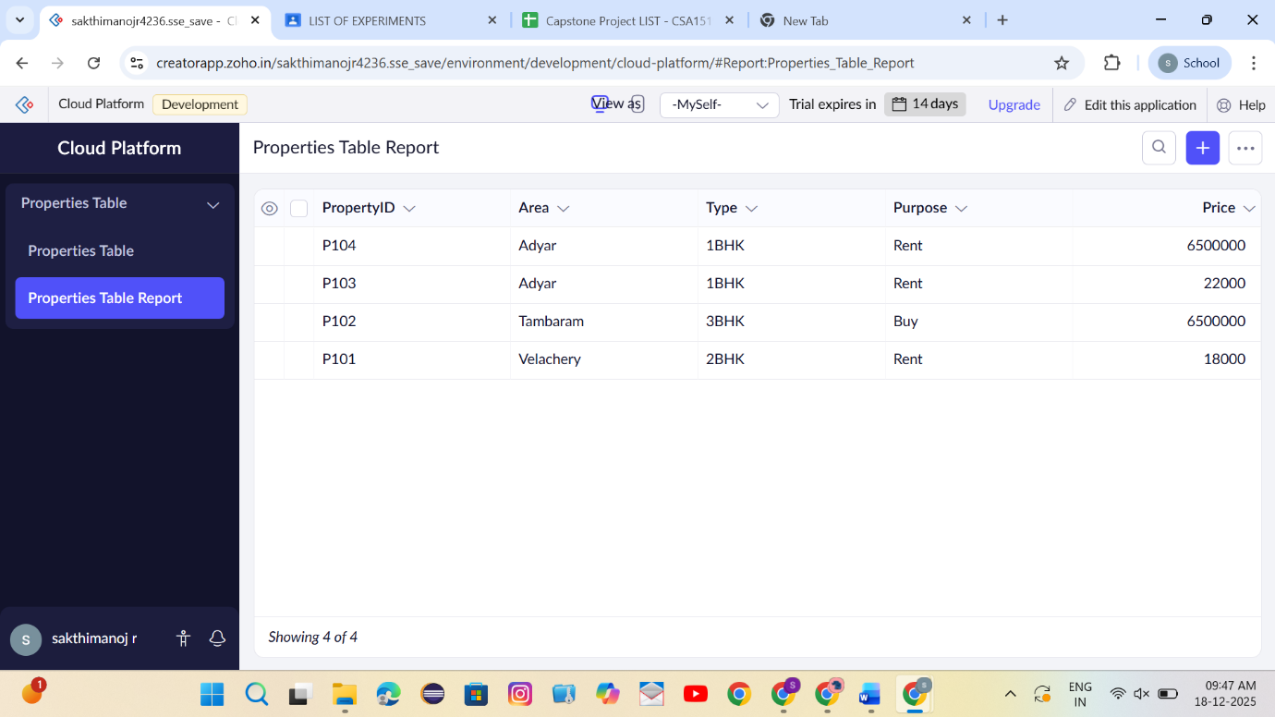

- User data stored and retrieved from cloud database.
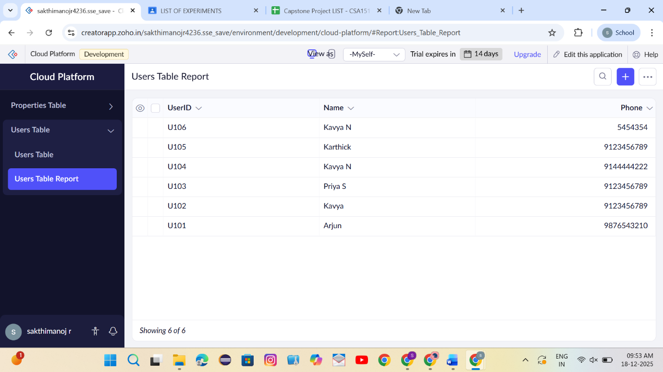

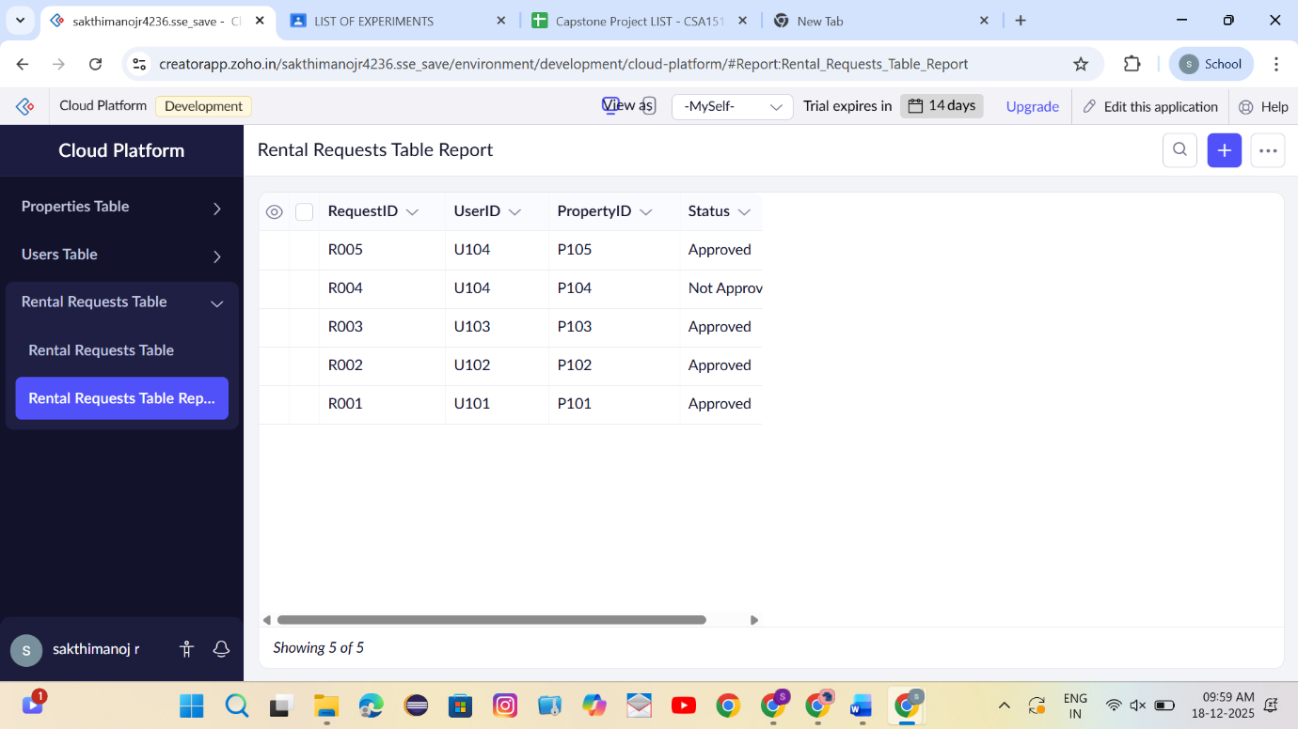

Result
Thus, a cloud-based Property Buying and Rental System was successfully created and deployed to demonstrate the SaaS model.

